Lab - 4
1. Write a JS for the following:
- Declare variable sum and x
- Assign 1 to variable x
- Assign 0 to variable sum
- Add variable x to variable sum, and assign the result to variable sum
- Print “ The sum is :”, followed by the value of variable sum

2. Combine the statements in Ques. 1 into a JS program that calculates and print the sum of integers from 1 to 10. Use While loop
3. Write a JS that outputs text that keeps displaying in the browser window the multiples of integer 2, namely 2, 4,8,16, etc. Your loop should not terminate (i.e., create an infinite loop). What happens when you run this program?
4. Do the following in JS
- Read ten integers and determine and display largest and smallest integers in the group
- Explore Block scope using ‘let’ with example
- Write a JS to perform all arithmetic operations

5. Function - Write a JavaScript program that uses functions to find the square of a given number entered as form input. You should use two functions one to calculate the square, while the other writes the result to the form.
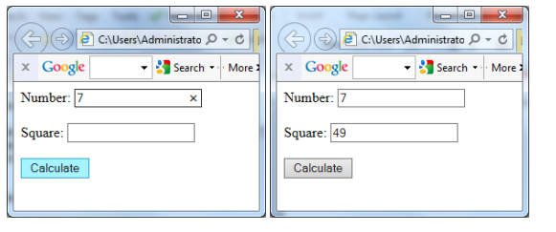
6.Create and read cookies using JavaScript.
7. Given as hardcopy

